Export statement
When we are defining environmental variables we can use the export statement:
- Export X=1
This way the specified variable will be accessible in all the subprocesses (compiled programs) which we run after defining that variable.
Here are examples of subprocesses using environmental variable:
- Example 1. A bash subprocess:
  - export X=1
  - bash -c 'echo $X'
- Example 2. A Python subprocess:
  - export X=1
  - python3 -c 'import os; print(os.environ["X"])'

Init system
That is a process which runs as the first one after kernel boots.

Shell
Shell is a program which allows using commands in terminal and returns outputs. Those commands are from the shell’s language. Popular shells:
- sh (Bourne Shell)
- bash (Bourne Again Shell)
On Linux both those shells are saved in the /bin/sh and /bin/bash respectively.

Processes

Daemons
Daemons are background, long running processes.

Commands
- ps aux – show all processes

Useful bash commands and CLI Linux tools

Commands outputs
There are two types of bash commands outputs:
- stdout (standard output)
- stderr (standard error)
The stdout is the normal output of a command – the result which it prints when it runs successfully.
The stderr is the error or warning message from a command.

Exit codes
Every bash command returns an exit code. Exit code = 0 means success and any other value means some kind of error.
We can access an exit code of a command by using $? after that command, for example:

Redirect an output of a command
We can redirect an output of a command:
- To a file:
  - Command > file – overwrite a file if it exist
  - Command >> file – append to a file if it exists
- To another command:
  - Command1 | command2 – output of the command1 becomes an input for the command2
- Redirect the standard output (stdout) to one location and standard error (stderr) to another location:
  - Command > filename1.txt > filename2.txt
- Redirect stdout and stderr to the same location:
  - Command > filename.txt 2>&1
- Hide the stdout and stderr (redirect it to the ‘black hole’):
  - Command > /dev/null 2>&1

Get a command output
- X=$(command) – Assign output of a commnd to an environental variable X

Grep
It is a tool for filtering text. For example we can:
- Filter a content of a file. Below command shows only those lines from the file.txt file which contains ‘error’ string:
  - Cat file.txt | grep “error”
- Filter output of some command. Below command shows only running processes related to nginx:
  - ps aux | grep nginx

Editing files context
For editing files the best tools are:
- sed - More information in the ‘Sed’ section of this document.
- Cat used together with heredoc and command redirection - More information in the ‘Heredoc’ section of this document.

Sed
Sed is used to replace all the strings matching the pattern with a new string in a specific file:
- sed -i ‘s/pattern/replacement/’ file_path
Patterns which are being matched to strings are using Regular Expressions, more information is here: link.

Heredoc
Heredoc is used in order to pass a multiline argument to a command:
- Command << EOF
Line1
Line2
EOF
For example it can pass a multiline text as an argument to the Cat command what will display all those lines.
If we additionally use the ‘>’ or ‘>>’ to redirect an output we can save multiline text to a file:
- Cat << EOF >> file_path
Line1
Line2
EOF

Tee
The tee command redirects an output of another command to both a terminal and a file. Example use cases:
- Command | tee filename - Save an output of the command in the given file and also write it in a terminal.
- Command | tee filename | another_command – save an output of the command in the given file and also redirect that output to another command.

Echo
The echo command prints a text. It can be used for example in order to save a text into a file.

Ls
Ls command is used for listing files contained in a directory and checking their permissions. Syntax:
- Ls [options] folder_path
Where folder _path is a path to the folder from which we want to list the content (files and folders).
Popular options:
- -l – show permissions, owner, size etc.
- -a - show all file, including the hidden ones (which name starts with a dot ‘.’).
- -d – Get information about the directory itself (given by the folder_path), not its content.

Mkdir
Create a folder. Syntax:
- Mkdir [options] folder path
Popular options:
- -p – Create the entire path. For example if we run ‘mkdir -p folder1/folde2 and both folders doesn’t exist yet, then it will create both of them.

Modifying files and folders permissions and ownerships

Chmod
Chmod is changing permissions for a specific file or folder. It uses this syntax:
- Chmod xxx file_path
Where xxx are numbers specifying the permissions.

Chown
Chown is changing an owner of a file or folder. It uses this syntax:
- Chown [options] [username][:usergroup] file_path
Where:
- Username – username of a new owner
- :usergroup (optional) a new group owner
Popular options:
- -R – change ownership of all the files and folders which are contained in the folder given by the file_path parameter.

Installing packages

Apt-get
Apt-get is a popular package manager used for installing different tools.
Popular commands:
- Apt-get update - Updates the list of available packages
- apt-get install <package> - Installs a package
- apt-get remove <package> - Remove a package

GPG key
The GPG keys are used to ensure that the packages which we install are secure. When we want to install packages from a new repository we might need to import ints GPG key to our system so apt-get trusts packages from it.

Loops

For loop
Iterate over a list:
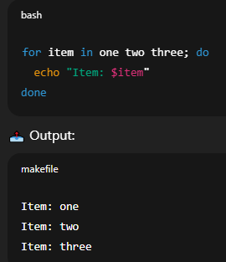
Iterate over a sequence of numbers:
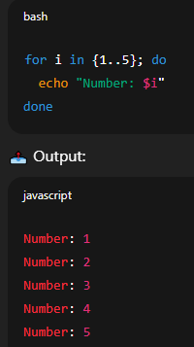
Iterate over a sequence of numbers with specified step:
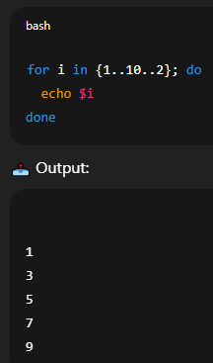

While loop
Syntax for the while loop:
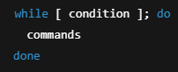

If statements
Syntax:
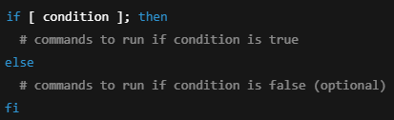
The condition must return either:
- true or false
- zero or non zero value
For example:
- [X -eq 10] condition compares environmental variable X to 10 and returns true or false.
- [command] condition runs a command which returns an exit code. If exit code = 0 that means true, any non zero value means false.

Sysctl
It is used to view and modify kernel parameters without rebooting the system.
Those parameters control how Linux kernel behaves, including things like:
- Networking settings
- Memory limits
- Process handling
- Security controls
Those parameters are stored in the /proc/sys/ directory.
If we change some parameters using the sysctl command, then those changes are not persistent across reboots.
If we want them to be consistent we need to create a .conf file in the /etc/sysctl.d/ folder and save those changes there.
For example this command:
- sysctl -w net.ipv4.ip_forward=1
changes the net.ipv4.ip_forward parameter which is stored in the /proc/sys/net/ipv4/ip_forward file.
If we want to have this parameter set up like this across reboots then we need to create a file like this:
- echo “net.ipv4.ip_forward=1” > /etc/sysctl.d/filename.conf

Isolating processes
We can isolate processes on Linux, such that they can:
- Use only a specific amount of resources (CPU, RAM)
- See and access only a specific files, other processes
For managing which resources processes can use, we are using cgroups.
For managing what processes can see we are using namespaces.

Cgroups
We can use cgroups (control groups) in Linux in order to control and limit the resource usage (CPU, RAM etc) of groups of processes.
Each cgroup get assigned a specific amount of resources.
We can use for example systemd or cgroupfs for managing cgroups.

Namespaces
Namespaces isolate what a process can see and access – such as files, processes, users, network interfaces and more.
Namespace is a group of processes for which we apply restrictions.

